Name: _____________________________________

Use your information about angles, parallel and perpendicular angles to work out all the marked angles on this shape.

You will need to use facts about corresponding angles, vertically opposite angles and others.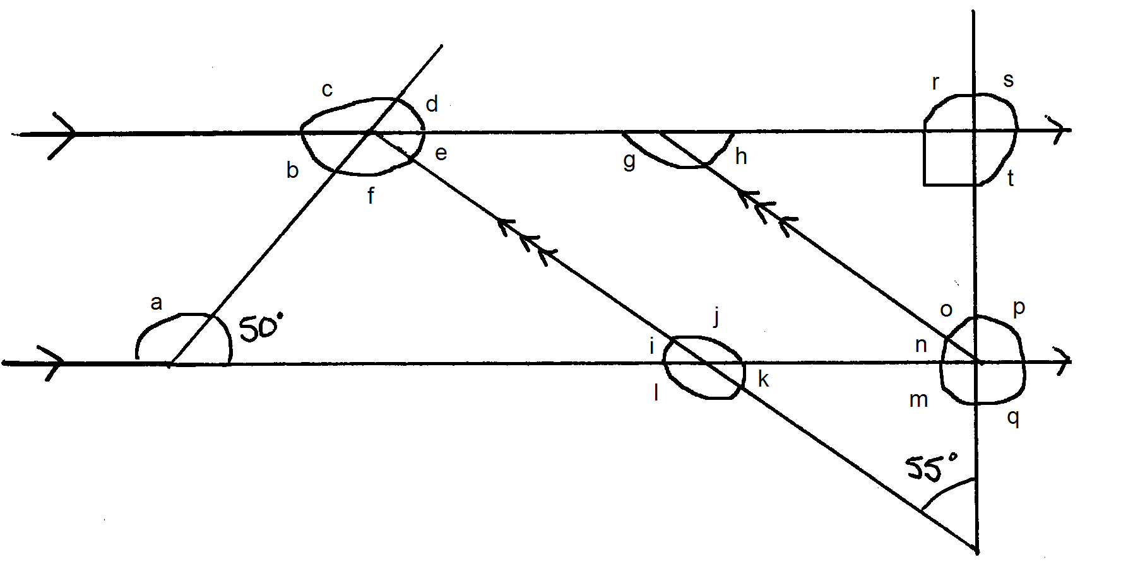

The lines marked with a > are parallel to each other.
The lines marked with >>> are parallel to each other.

Use the space below for any working out you need to do.

Name: _____________________________________

Use your information about angles, parallel and perpendicular angles to work out all the marked angles on this shape.

You will need to use facts about corresponding angles, vertically opposite angles and others.

The lines marked with a > are parallel to each other.
The lines marked with >>> are parallel to each other.

Use the space below for any working out you need to do.

